|  |  |
| --- | --- |
| NAME | Muhammad Arslan Raza |
| ROLL# | 2020-EE-403 |

**Lab 12: Open Ended Lab (**Searching & Sorting**)**

**Objective:**

The objective of this problem set is how to write different programs on compiler

**Task 1:**

Write a Python program to sort a list of elements using the insertion sort algorithm.

**Code:**  
def insertion_sort(l):

for i in range(1,len(l)):

value=l[i]

index=i

while index>0 and l[index-1]>value:

l[index]=l[index-1]

index=index-1

l[index]=value

l=[45453,884644,454359,64564,34462,5644]

insertion_sort(l)

print("sorted array :" + str(l))

**Output:**



**Task 2:**

Write a Python program for binary search as it shows that specific element is present in list or not.

**Code:**

def binary_search (array,left,right,x ):

if right >= left:

mid=(right+left)//2

if array[mid]==x:

return mid

elif array[mid]>x:

return binary_search(array,left,mid-1,x)

else:

return binary_search(array,mid+1,right,x)

else:

return -1

array=[22,5,4,10,7]

x=10

result=binary_search(array,0,len(array)-1,x)

if result != -1 :

print ("Element is present in list at index ", str(result))

else:

print ("Element is not in the list")

**Output:**

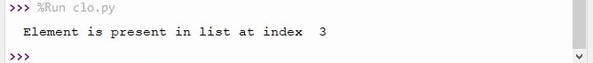

**Conclusion:**

Today in this lab I learn how to sort a list of elements using the insertion sort algorithm. And write a program for binary search as it shows that specific element is present in list or not.